Video Library Schema

Tables:-

1.library card master

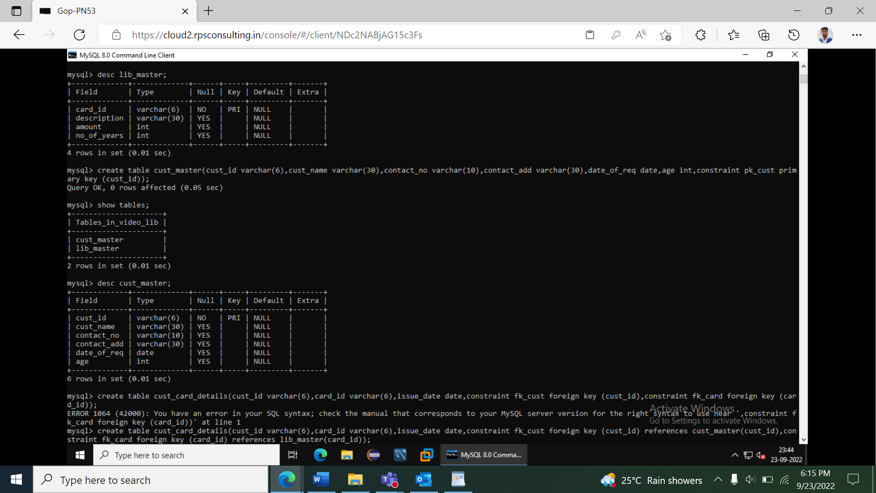

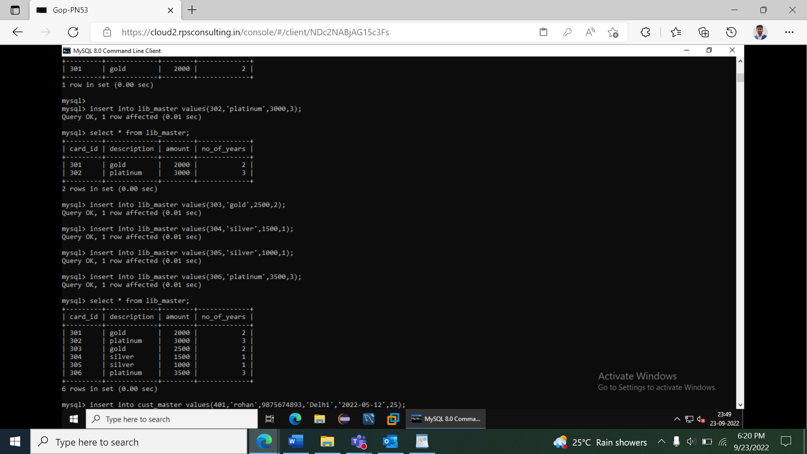

2.customer master

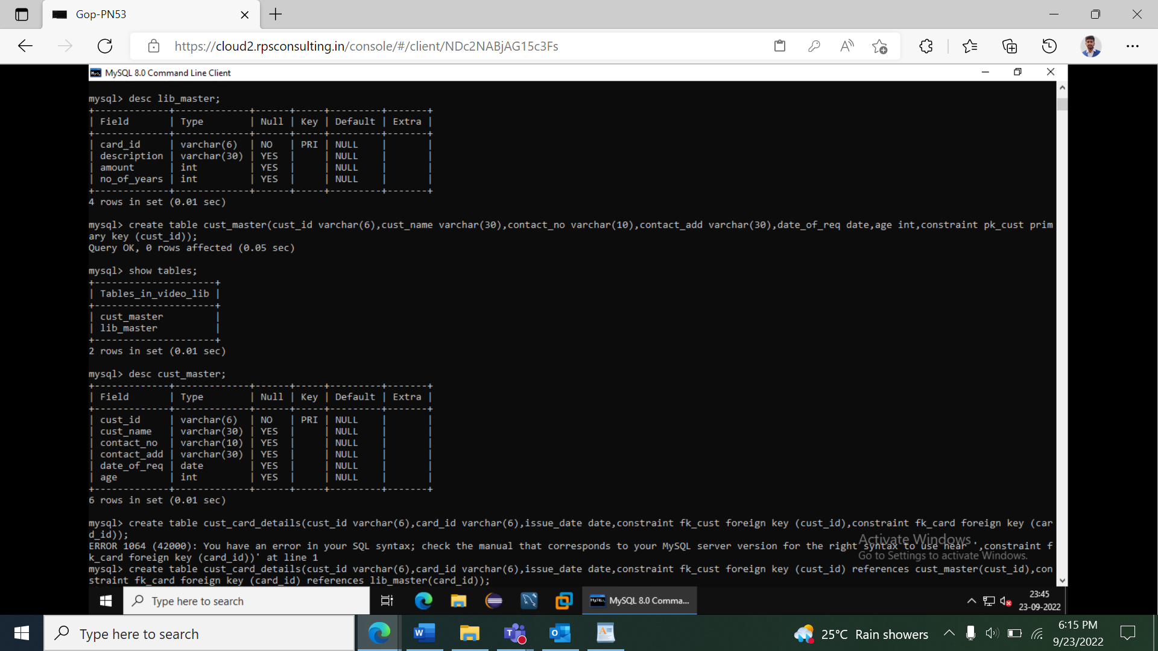

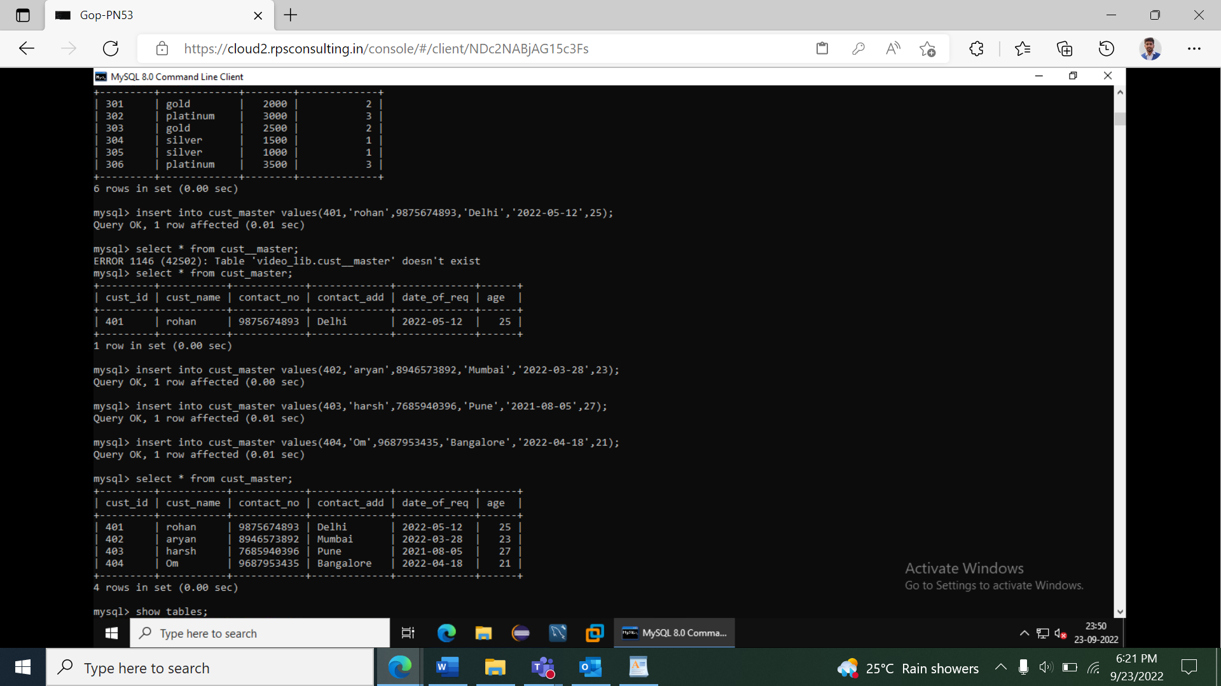

3.customer card details

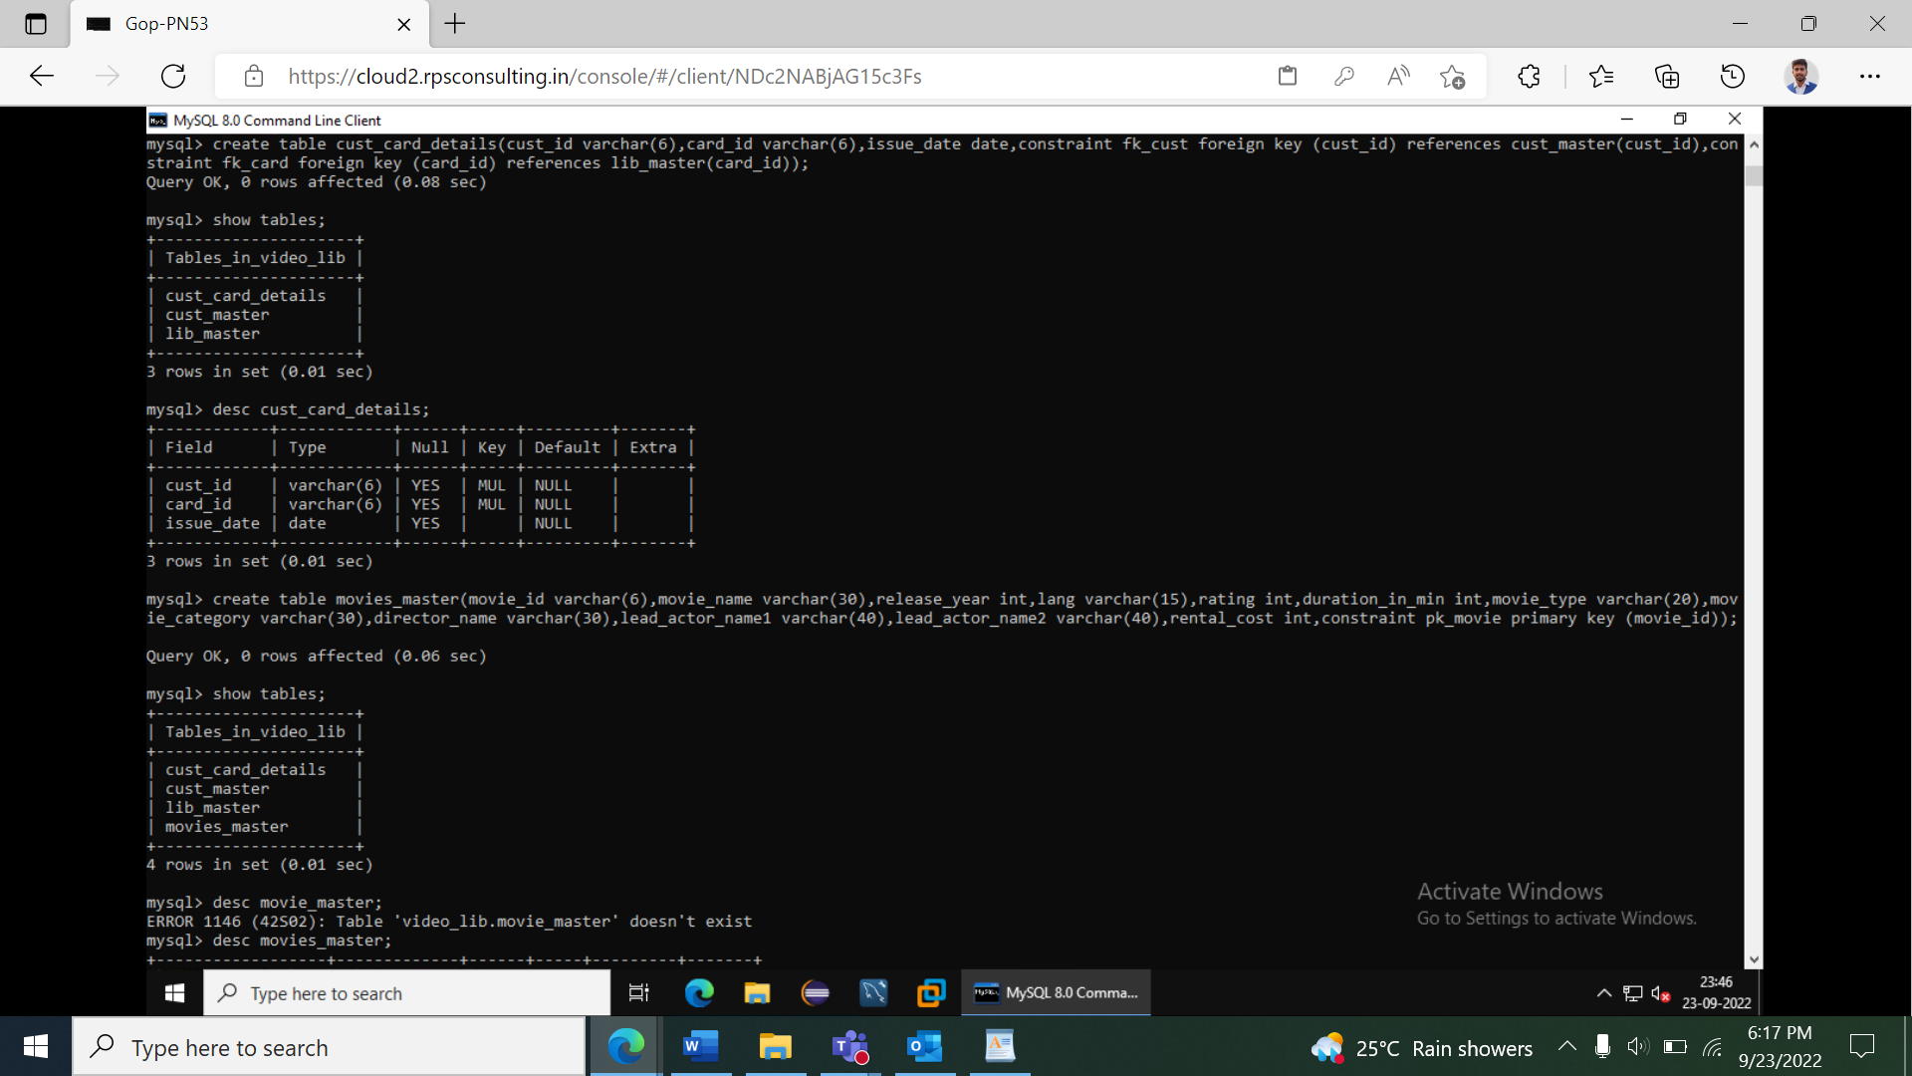

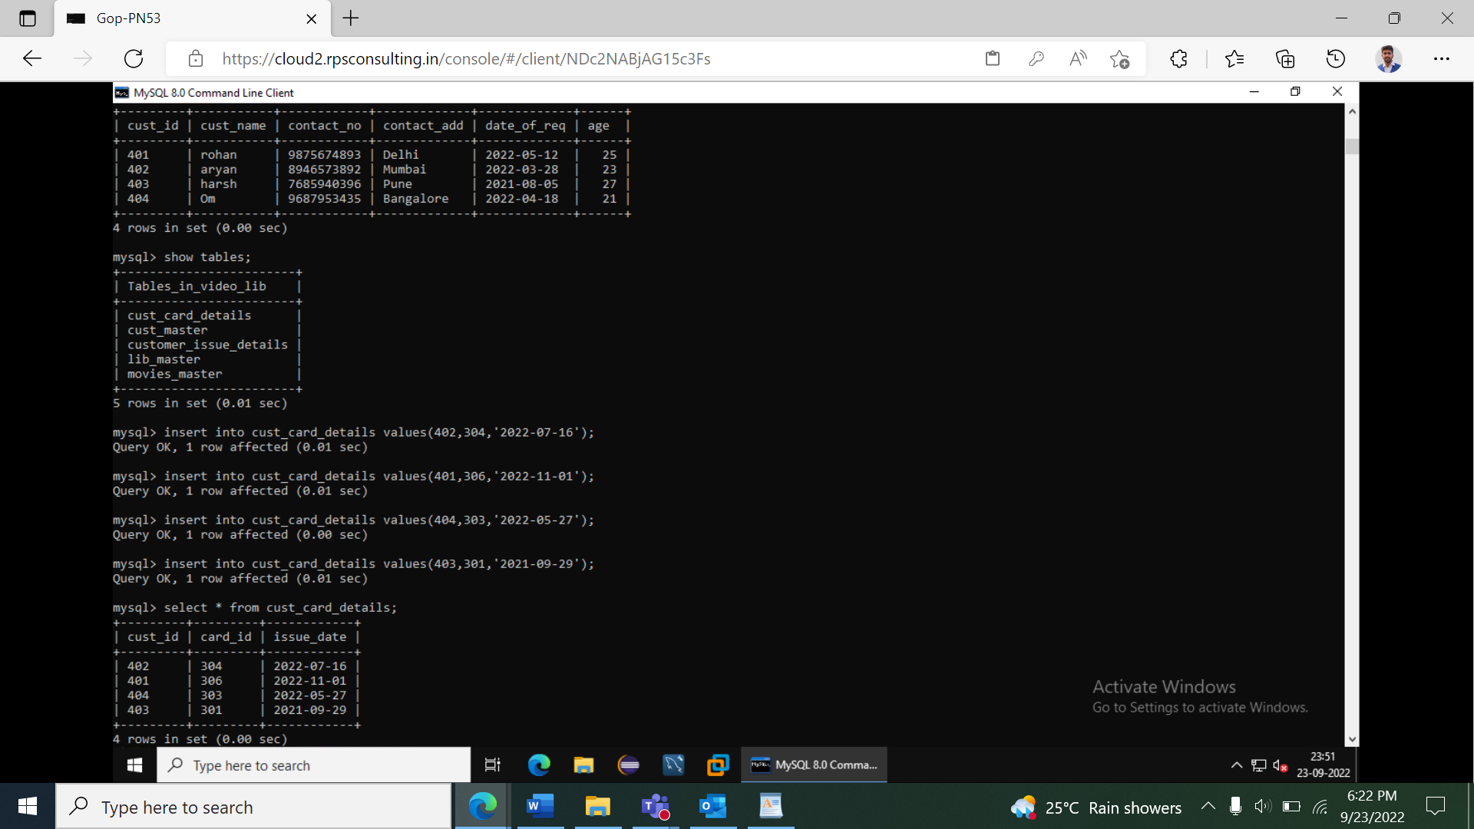

4.movies master

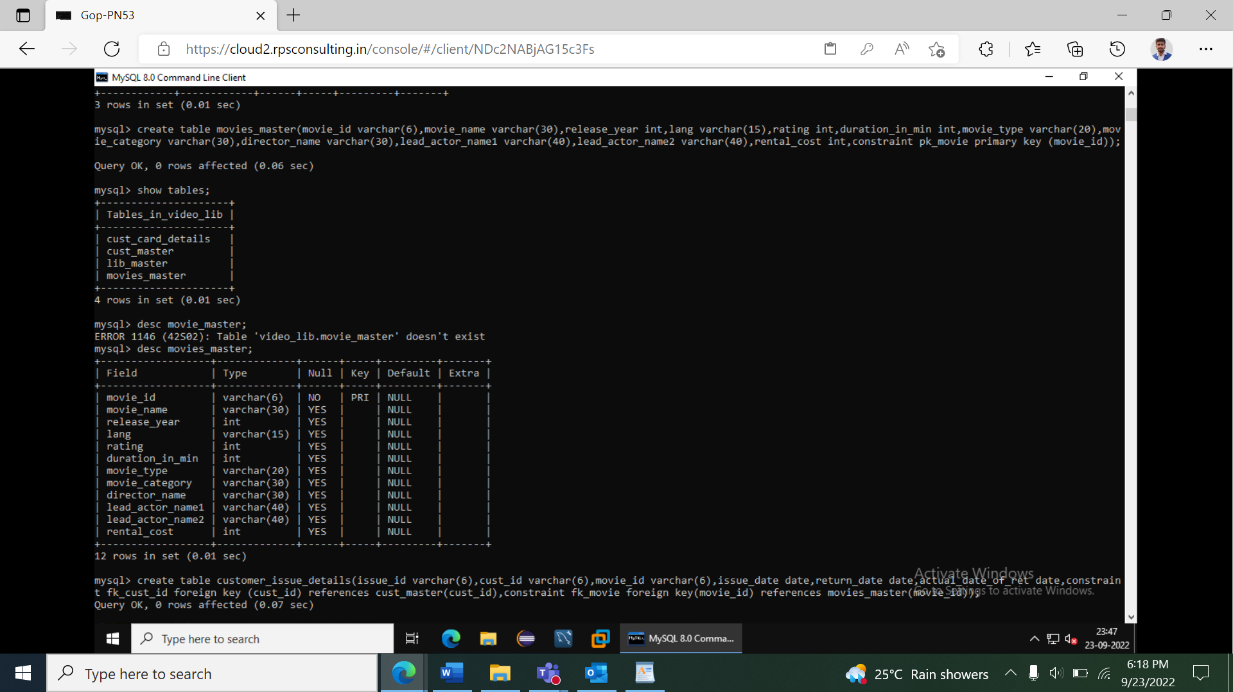

5.customer issue details

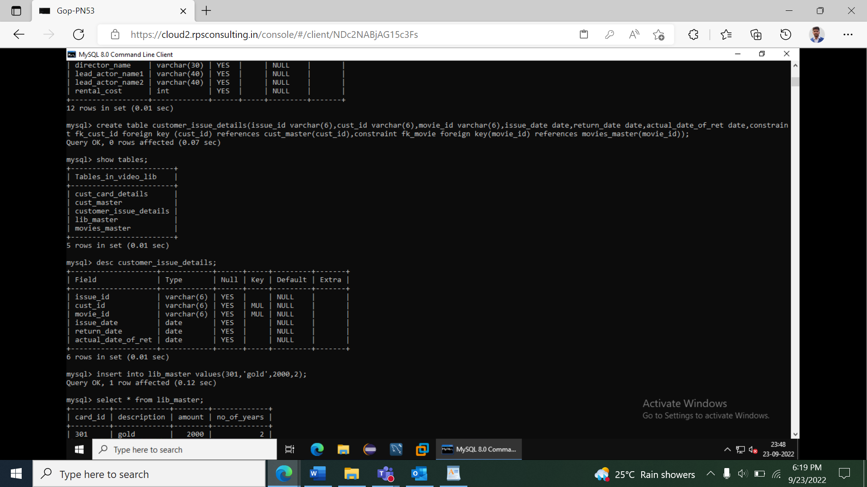

|  |
| --- |
| Video Library Queries |
|  | ---------------------- |
|  |  |
|  | 1.Write a query to display movie names and number of times that movie is issued to |
|  | customers. Incase movies are never issued to customers display number of times as 0. Display |
|  | the details in sorted order based on number of times (in descending order) and then by |
|  | movie name (in ascending order). The Alias name for the number of movies issued is |
|  | ISSUE_COUNT. |
|  |  |
|  |  |
|  | 2.Write a query to display id,name,age,contact no of customers whose age is greater than 25 |
|  | and and who have registered in the year 2012. Display contact no in the below format +91- |
|  | XXX-XXX-XXXX example +91-987-678-3434 and use the alias name as "CONTACT_ISD". If the |
|  | contact no is null then display as 'N/A' Sort all the records in ascending order based on age |
|  | and then by name. |
|  |  |
|  | 3.Write a query to display the movie category and number of movies in that category. Display |
|  | records based on number of movies from higher to lower order and then by movie category |
|  | in ascending order.Hint: Use NO_OF_MOVIES as alias name for number of movies. |
|  |  |
|  |  |
|  | 4.Write a query to display the customer id, customer name, year of registration,library card |
|  | id, card issue date of all the customers who hold library card. Display the records sorted by |
|  | customer name in descending order. Use REGISTERED_YEAR as alias name for year of |
|  | registration. |
|  |  |
|  |  |
|  | 5. .Write a query to display issue id, customer id, customer name for the customers who have |
|  | paid fine and whose name starts with 'R'. Fine is calculated based on return date and actual |
|  | date of return. If the date of actual return is after date of return then fine need to be paid by |
|  | the customer order by customer name. |
|  |  |
|  |  |
|  | 6. Write a query to display the customer id, customer name,contact number and address of |
|  | customers who have taken movies from library without library card and whose address ends |
|  | with 'Nagar'. Display customer name in upper case. Hint: Use CUSTOMER_NAME as alias |
|  | name for customer name. Display the details sorted in ascending order based on customer |
|  | name. |
|  |  |
|  | 7. Write a query to display the movie id, movie name,release year,director name of movies |
|  | acted by the leadactor1 who acted maximum number of movies .Display the records sorted in |
|  | ascending order based on movie name. |
|  |  |
|  |  |
|  | 8. Write a query to display the issue id,issue date, customer id, customer name and contact |
|  | number for videos that are issued in the year 2013.Display the records in decending order |
|  | based on issue date of the video. |
|  |  |
|  |  |
|  | 9. .Write a query to display number of customers who have registered in the library in the |
|  | year 2012 and who have given/provided contact number. <br> Hint:Use NO_OF_CUSTOMERS |
|  | as alias name for number of customers. |
|  |  |
|  | 10. Write a query to display the customer id , customer name and number of times movies |
|  | have been issued from Comedy category. Display only for customers who has taken more |
|  | than once. Hint: Use NO_OF_TIMES as alias name Display the records in ascending order |
|  | based on customer name. |